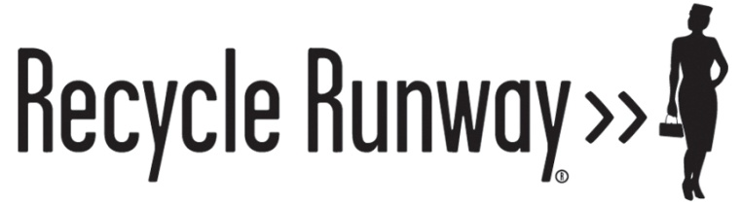

Biographical Information on Nancy Judd



Nancy Judd is the founder and principal of Recycle Runway, which she started in 2000. Ms. Judd is an environmental educator, artist and recycling consultant and has been working in the field of recycling since 1990.

In 1998, while working for the City of Santa Fe, Ms. Judd helped to found an annual event called the Recycle Santa Fe Art Market. The weekend long recycled art market and exhibit begins with a trash fashion contest. Ms. Judd began making recycled garments to promote the contest and soon had an impressive collection of recycled outfits. The National Recycling Coalition invited her to put on a recycled fashion show at their annual conference in 2003 and soon she was booked all over the country!

During her five years at the City of Santa Fe, Ms. Judd served as president of the New Mexico Recycling Coalition for 1½ years. In 2000 she left the city, started a consulting business, and served as the Executive Director of the New Mexico Recycling Coalition through 2005.

During this time Nancy Judd traveled through the US giving over 30 recycled fashion shows, accompanied by youth presentations.

In 2006 Ms Judd decided to turn all of her attention to her recycled fashion project full-time. She renamed the business Recycle Runway and realized that exhibitions in airports would give her a larger audience for her message of environmental stewardship.

Encouraging people to reflect upon their personal environmental impact and take action to reduce their carbon footprint is the heart of Nancy Judd’s mission for Recycle Runway. Ms. Judd strives to live her life and run her business on these principles. She believes that it is the culmination of our individual actions that created the environmental crisis we now face, and that the solution lies in our personal daily choices at home and work. She hopes to inspire people in a fun, creative and positive way to change the decisions we make around food, consumption, transportation, recycling and reuse.

Ms. Judd grew up in Portland Oregon and received her BA from Pitzer College (Claremont, California) in Art and Sociology. She spent time at the Laguna Beach Art Institute and the University of Georgia’s art program in Cortona, Italy. A self-taught seamstress, Nancy Judd has been sewing, designing clothing and jewelry, and making art since she was a child.

She began her career in the recycling field immediately after she graduated from college in 1990 by developing a recycling program for Pitzer College. She completed a Solid Waste Certification Program at the University of Los Angeles, California while serving as recycling coordinator for the Los Angeles Conservation Corps. In 1995 she moved to Santa Fe, New Mexico to work as waste reduction/recycling coordinator for the City of Santa Fe. In 2000 she became the executive director of the New Mexico Recycling Coalition and in 2006 formalized Recycle Runway into a full time business venture.

ACCOLADES
Pitzer College: Alumna of the Year, 2009
Green Party: Green Values Award, 2009
City of Santa Fe: Sustainability Award, 2009
Wall Street Journal: Front Page Article, 2009
Koldinghus Museum, Denmark: Sustainable Fashion Exhibition, 2009

COMMUNITY SERVICE
Neighborhood Organizer, Barak Obama Campaign for President, Summer/Fall 2008
Founder, Recycle Santa Fe Art Festival 1998-2010
Television Interviewer, Santa Fe Cable Access Channel 8 weekly show, 2001 - 2004
Big Sister, Big Brothers/Big Sisters of Santa Fe, Summer 2000 – 2006
Appointed Member, Sustainable Santa Fe Commission, 1999-2000, 2002-2004
President, New Mexico Recycling Coalition, 1999-2000
Board Member, Santa Fe Beautiful, 1995-2000

