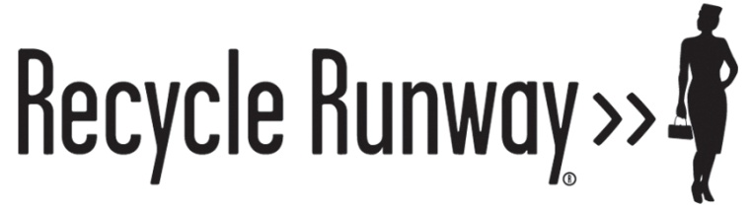

Recycle Runway strives to change the way the people live on the earth through innovative environmental educational programs and couture fashions made from trash. The Recycle Runway fashions are exhibited in high-traffic airports to grab travelers’ attention and inspire personal action. Community-based presentations and workshops launch young peoples' imaginations while providing information on how to conserve resources. Recycle Runway partners with businesses, non-profits, governmental agencies, foundations and individuals who actively support environmental conservation.

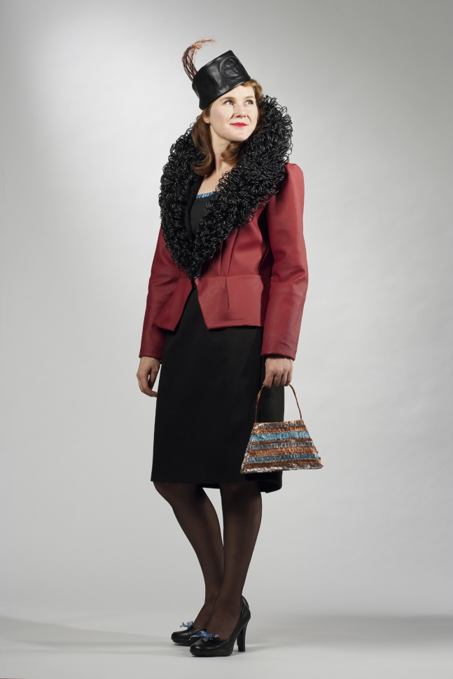
The Garments
Each garment is a unique, hand-sewn design that takes between 100-450 hours to create and is made from 99% recycled or reused materials. The specific properties of each waste item are used to create elegant garments that from afar appear to be made from anything but trash! Ms. Judd recycles fashion styles from 1900s-1950s in her designs, and all can be worn for short periods of time. Her goal is to design all of her garments to last at least 100 years, thus inspiring generations of people to reduce their environmental impact.

Garments include: a faux fur jacket made with endless loops of cassette and video tape; a dress train made of origami junk mail fans sewn together like fish scales; and an evening gown glittering with thousands of pieces of crushed recycled glass.

Many of the garments are sponsored by organizations such as Toyota®, Coca-Cola®, Target®, Starbucks®, Novelis Recycling, the Glass Packaging Institute and the Parish of Baton Rouge. Recycle Runway provides these companies a means of sharing their environmental programs with the public in a creative context.
Convertible Trashique, sponsored by Toyota

Environmental Education
The intent of Recycle Runway is to transform the way we think about waste and encourage people to change how they use our natural resources. The garments capture people’s attention so that Ms. Judd can engage them in a “conversation” about environmental stewardship issues in a fun and unique way. This is currently accomplished in two ways: 1) airport exhibits, and 2) youth presentations.

The Airport Project
The intent of the Airport Project is to exhibit the Recycle Runway Collection in glass cases in airports around the world, encouraging millions of people, with time to spare, to reflect upon sustainability issues in a creative, fun, and eye-catching venue. The Recycle Runway exhibit showcases ways that creativity is used to address the sustainability issues facing our planet.
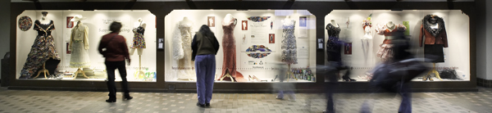
Albuquerque Sunport Airport Exhibit

Airport Exhibition Schedule and History:

- Hartsfield-Jackson Atlanta International Airport, Georgia, Fall 2010-Fall 2011
13.5 million estimated viewers
- Phoenix Sky-Harbor International Airport, Arizona, February-August 2010
6.5 million estimated viewers
- Pittsburgh International Airport, Pennsylvania, August 2008-June 2009
4 million estimated viewers
- Albuquerque International Sunport, New Mexico, October 2007-January 2008
500,000 estimated viewers

Youth Education
Working with youth is at the core of the Recycle Runway mission. Ms. Judd gives presentations and workshops to young people across the country using her recycled garments to capture children’s imaginations.
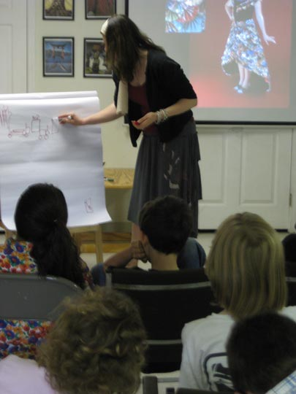
Presentations
Ms. Judd shows photos of the Recycle Runway garments, engaging the kids in an interactive conversation about recycling and environmental issues. She maps-out with the students how materials like junk mail are made, the resources used in the process,and what happens when they are thrown away or recycled. At the end of the presentation, Nancy invites the kids to help her make a new garment (see below).

Workshops
Ms. Judd gives hands-on workshops through schools and organizations such as the George O’Keefe’s Summer Art and Leadership Program for Girls. In these workshops students receive the above presentation and then transform trash into new garments or usable items such as gift boxes or candle holders.
Presentation in Los Angeles, CA.

The Youth Eco-Dress
Students from the presentations and workshops are invited to help Ms. Judd create a new garment called the Youth Eco-Dress. Each child writes their name and environmental pledge on a recycled strip of office paper. The strips of paper are currently being made into paper-link-chains and sewn to a Scarlett O'Hara style dress to be displayed at the Recycle Runway exhibit in the Hartsfield-Jackson Atlanta International Airport in the Fall of 2010.

Partners
Recycle Runway is excited to work with and promote businesses and organizations that are demonstrating their commitment to positively meet the triple bottom line: People, Planet and Profit. At each Airport Exhibit, partners are encouraged to help sponsor the Exhibit in return for exposure in the cases and marketing materials.

