MEDIA RELEASE

Date: December 23, 2008
Contact: Nancy Judd, 505-577-9712, Nancy@RecycleRunway.com

Recycle Runway’s Campaign for Change Couture Collection goes to the presidential inauguration!

Santa Fe Artist and environmental educator Nancy Judd will take her newest collection of recycled garments, the Campaign for Change Couture Collection to Washington DC, for the inauguration of President-elect Barack Obama in January, 2009

The garments are fashioned out of discarded campaign materials; each is a celebration of the millions of people who volunteered to assure the election of Barack Obama as the next president of the United States.

Ms. Judd was a dedicated Obama volunteer for six months in Santa Fe, New Mexico. The day after the election she went “dumpster diving” behind the Obama Campaign headquarters in northern New Mexico and filled her car with historic campaign materials. Ms. Judd is transforming these left over door hangers, yard signs, posters, etc into a collection of elegant garments.

The first garment (below) is made from yard signs, the second is a man’s winter coat covered with paper door hangers, the third is a woman's “swing coat” made from voter registration materials, the fourth will be a ball gown made from posters.

The Campaign for Change Couture Collection will be featured at the Green Inaugural Ball on January 17th and a reception to honor the New Mexico Congressional Delegation on January 19th.
Ms. Judd has also contacted numerous other inaugural events that include another green ball hosted by Al Gore on January 19th, New Mexico’s Land of Enchantment Inaugural Ball, the Hope Youth Ball, the Peace Ball, The Creative Coalition Gala, and the Dance for Equality.

While in DC Ms. Judd will give presentations to youth groups (as she is doing throughout the Santa Fe School District) encouraging recycling and environmental stewardship. She also invites the students to make a garment with her called the ECO-YOUTH dress.

Ms. Judd is soliciting donations from individuals and organizations that want to support her trip to Washington DC and associated educational efforts. Details are attached.

The mission of Recycle Runway it to change the way the world thinks about the environment through innovative educational programs and couture fashions made from trash. Elegant garments created from recycled materials are exhibited in high-traffic airports to grab travelers’ attention and inspire personal action. Community-based presentations and workshops launch young peoples' imaginations while providing information on how to conserve resources on a grassroots level. Recycle Runway partners with businesses, non-profits, governmental agencies, foundations and individuals who actively support environmental conservation. www.RecycleRunway.com.

Contact Nancy Judd for more information and for high resolution files of the following images.

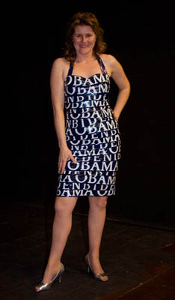
Made from Obama Yard Signs
Photo my Katie Macaulay

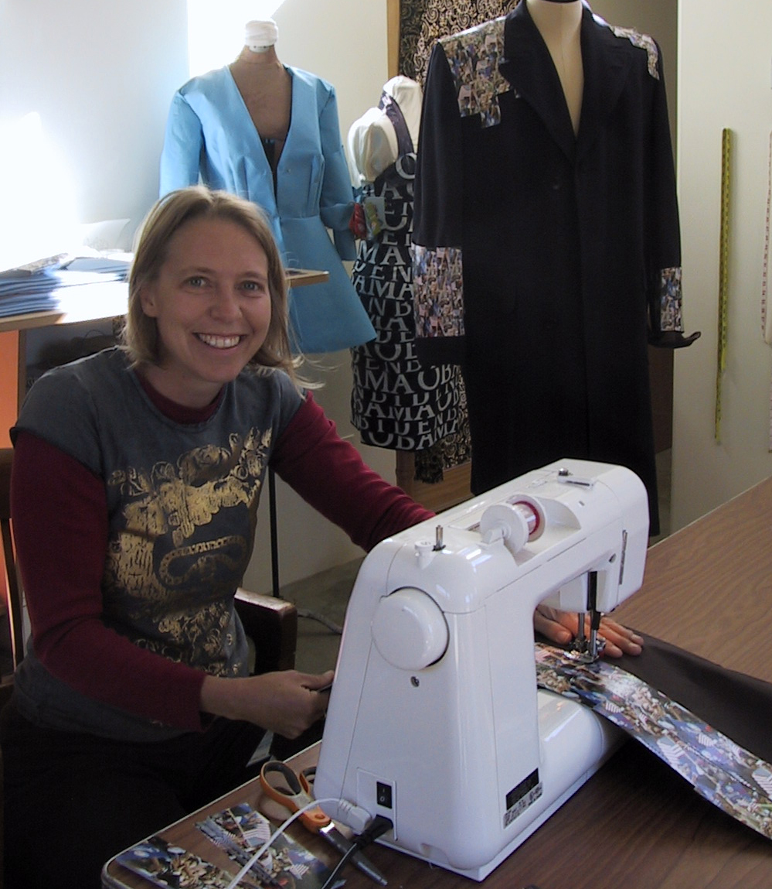
English Bird, Executive Director of the New Mexico Recycling Coalition helps Ms. Judd work on the second garment (pictured in the background) in the collection: a man’s winter coat covered with door hangers from the campaign.
Photo by Nancy Judd

